Gauss’s Law states: “The total outward flux of the electric field intensity, $\vec{E}$ over any closed surface in free charge space is equal to the total charge enclosed in the surface divided by $ϵ_{0}$”
$$\int_{vol}^{ }{{∇⋅\vec{E}(ρ}_{v}) dv}=\frac{1}{ϵ_{0}}\int_{vol}^{ }{ρ_{v} dv→\oint_{S}^{ }{\vec{E} dS}=\frac{Q}{ϵ_{0}}}=\frac{q}{ϵ_{0}}$$
$$Q=Ψ=\int_{0}^{π}{\int_{0}^{2π}{\vec{D}*R^{2}*\sin\left(θ\right)dθ}dϕ}$$
$$Q=\vec{D}*4πR^{2}$$
$$\vec{D}=\frac{Q}{4π*R^{2}}=\frac{q}{4π*R^{2}}\hat{a_{R}}$$
In Free Space, $D=ϵ_{0}E$, so $\vec{E}=\frac{q}{4π*ϵ_{0}*R^{2}}\hat{a_{R}}$
$$R^{2}={\left|R\right|}^{2}$$
$$\hat{a_{r}}=\frac{\vec{R}}{\left|\vec{R}\right|}$$

Electrical flux density: $\vec{D}=ϵ_{0}\vec{E}+\vec{P}$
Elic susptiby(chi e) in terms of E $P=χ_{e}ϵ_{0}\vec{E}, D=ϵ_{0}\vec{E}+ϵ_{0}χ_{e}\vec{E}=ϵ_{r}ϵ_{0}\vec{E}=ϵ_{0}\left(1+χ_{e}\right)\vec{E}→χ_{e}=ϵ_{r}-1$

$$\vec{D}=ϵ_{r}ϵ_{0}\vec{E}, \vec{P}=ϵ_{0}χ_{e}\vec{E}→$$
P as a function of D $\vec{D}=ϵ_{0}ϵ_{r}\left(\frac{\vec{P}}{ϵ_{0}χ_{e}}\right)→\vec{P}=\left(\frac{ϵ_{r}-1}{ϵ_{r}}\right)\vec{D}$

$$\vec{D}=ϵ_{r}ϵ_{0}\vec{E}=ϵ\vec{E}$$
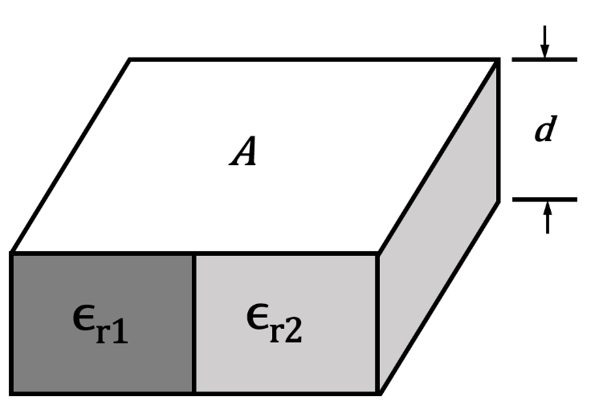
Absolute permittivity: $ϵ=ϵ_{r}ϵ_{0}$
$$ρ_{s}=\frac{Q}{A}$$
$$W_{e}=\frac{Q^{2}}{CV}$$
$$C_{1}=\frac{ϵ_{0}ϵ_{r_{1}}A_{1}}{d}$$
$$C_{2}=\frac{ϵ_{0}ϵ_{r_{2}}A_{2}}{d}$$

